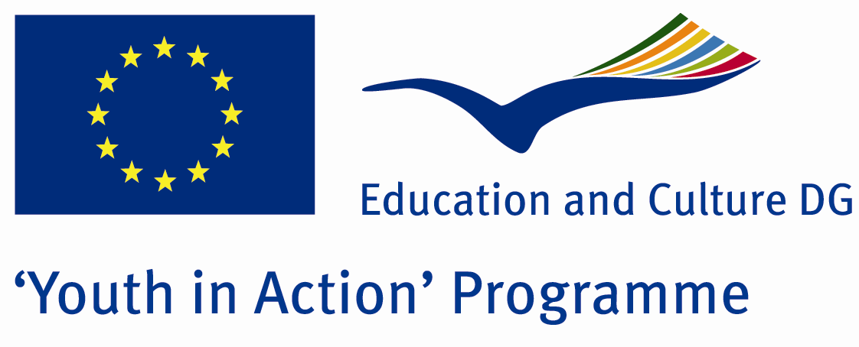

Give Right To The Life



ACTION 4.3 – Training And Networking

14-20th August 2011

Mugla/TURKEY

Please contact directly to;

adventurerpeacepigeons@gmail.com

Project Summary;
Maybe there is nothing as horror as this invention in the world… I try to mention about guns… and of course invention of gunpowder… In the first times, the guns were woring just only by gunpowder… but now, they were changed terrifically and ststed to lead the big horror disasters as biological, chemical and cosmic… All the countries are talking about peace all the time… but do you notice that they use the most money for the gun and improving them? just only because of these guns, do you notice that how many people die? If the countries give the money which spent for the gun to small and poor countries for the food, do you know that how many people will be saved from the disasters of famine?
To sum up, in this project, we will try to importance of peace… we try to give imformaiton the importance of disarmament…. and we want to make this project with you… we want to see you as our partner in this Project….

Project Title; Give Right To The Life

Date and Venue; 14-20th August 2011 Mugla/TURKEY

Target Group; Non profit/non governmental organization, Public body, Body active at European level in the field of youth (ENGO), Informal group of young people, e.t.c…

Participants; 5 people from each country (18 - 25). Totally 8 countries.

Conditions; Accommodation, board and programme costs will be financed through European Commission Youth in Action Programme (Action 4.3). Travel costs will be reimbursed in 70% (APEX Tarrifs). Organizations from all 27 EU member countries plus Liechtenstein , Norway and Iceland are eligible to take part.

Working language: English

Organizer; Discovery And Adventure Group

How to apply: If you are interested, please send your Part III forms to
0090 216 483 21 67 by FAX please. (Fulfilled Part III which you can find in the attachment, of course signed and stamped) ..

Note: jpeg is not allowed..please send by fax…

Next step 2;
Original send via regular post to this address please:

Ertan DERİN
Öner İnşaat
Abdulhalik Renda Cd.
Parlar Sk. No:4 Pendik/İSTANBUL

If you have any questions you may contact with: adventurerpeacepigeons@gmail.com

Deadline for application; until 20th January 2011.

For Further information:
Contact Person
Ertan DERİN
Öner İnşaat
Abdulhalik Renda Cd.
Parlar Sk. No:4 Pendik/İSTANBUL

e-mail : adventurerpeacepigeons@gmail.com
Mobile : 0090 542 393 93 90
Fax : 0090 216 483 21 67

